Ashley Serrano
Project Submission 7-1
GRA-310 Online
SNHU

Screenshot of the W#C Index/Home Page

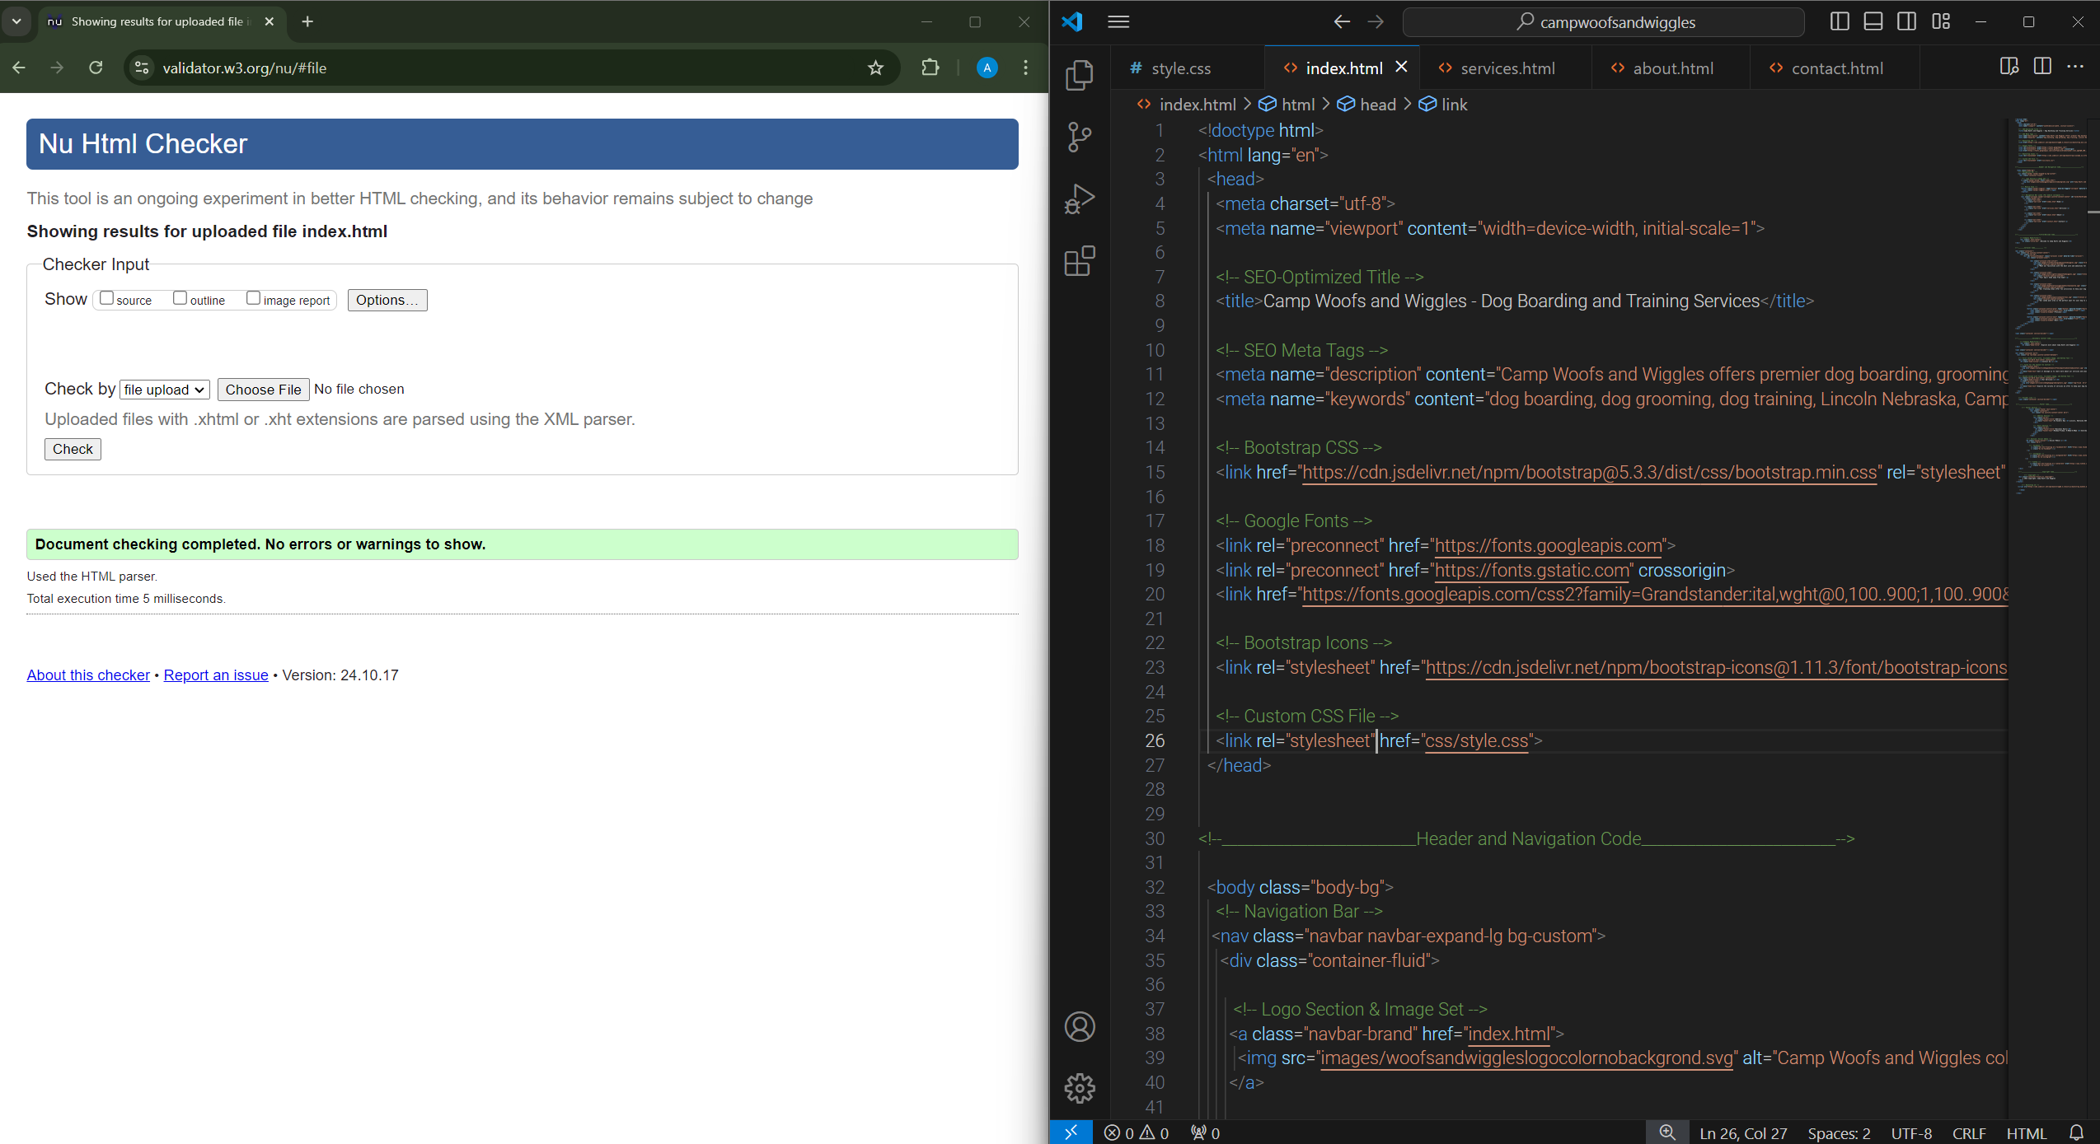

Screenshot of the W#C Service Page

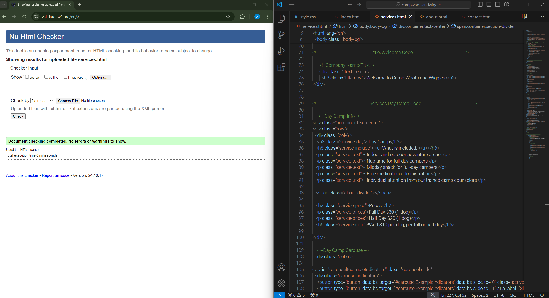
Screenshot of the W#C About Us Page

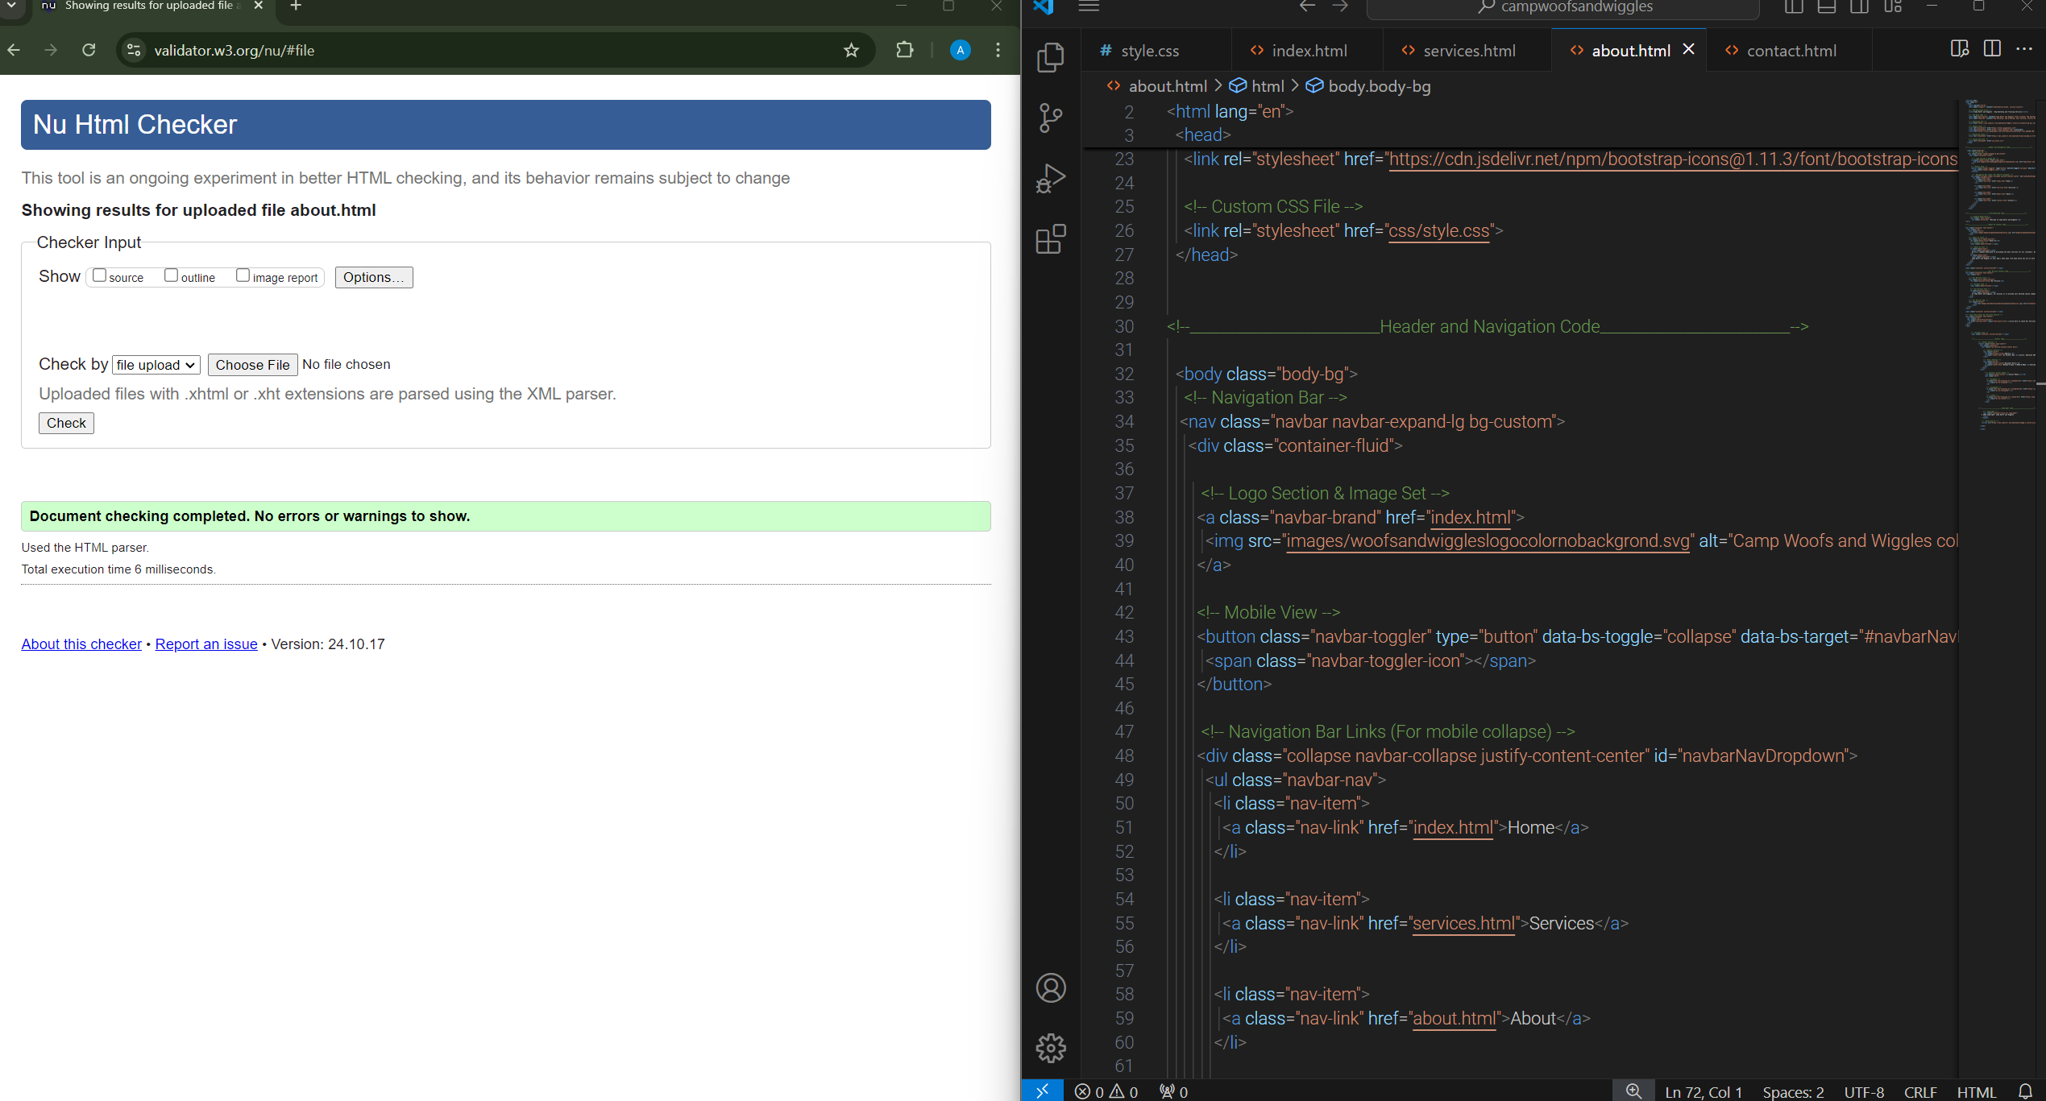

Screenshot of the W3C Contact Page

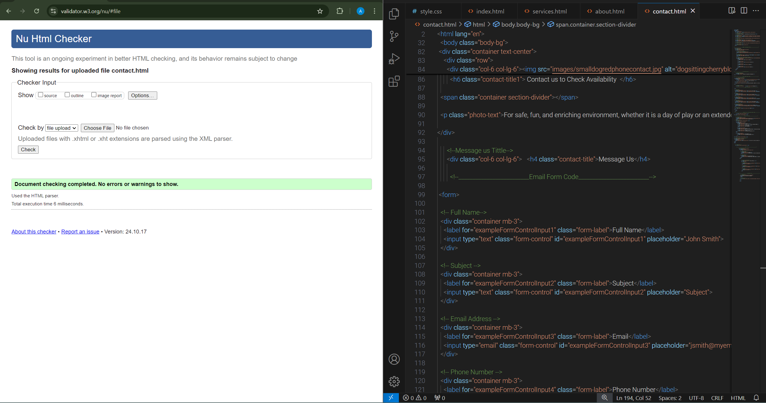

OAR Attributions:

All 21 images were created using AI-generated technology.

(PS. At the place I used to create these images when I tried to check their attribution, all It said was they were free, and no attribution was needed)

